Step 1 : Dowload and extract the following springboot application from the following link
https://drive.google.com/file/d/1Te3FJFm3oA3D8sbG3QYqkRWMxfpFxd3U/view?usp=sharing
Step 2 : Open the project with Intellij and run
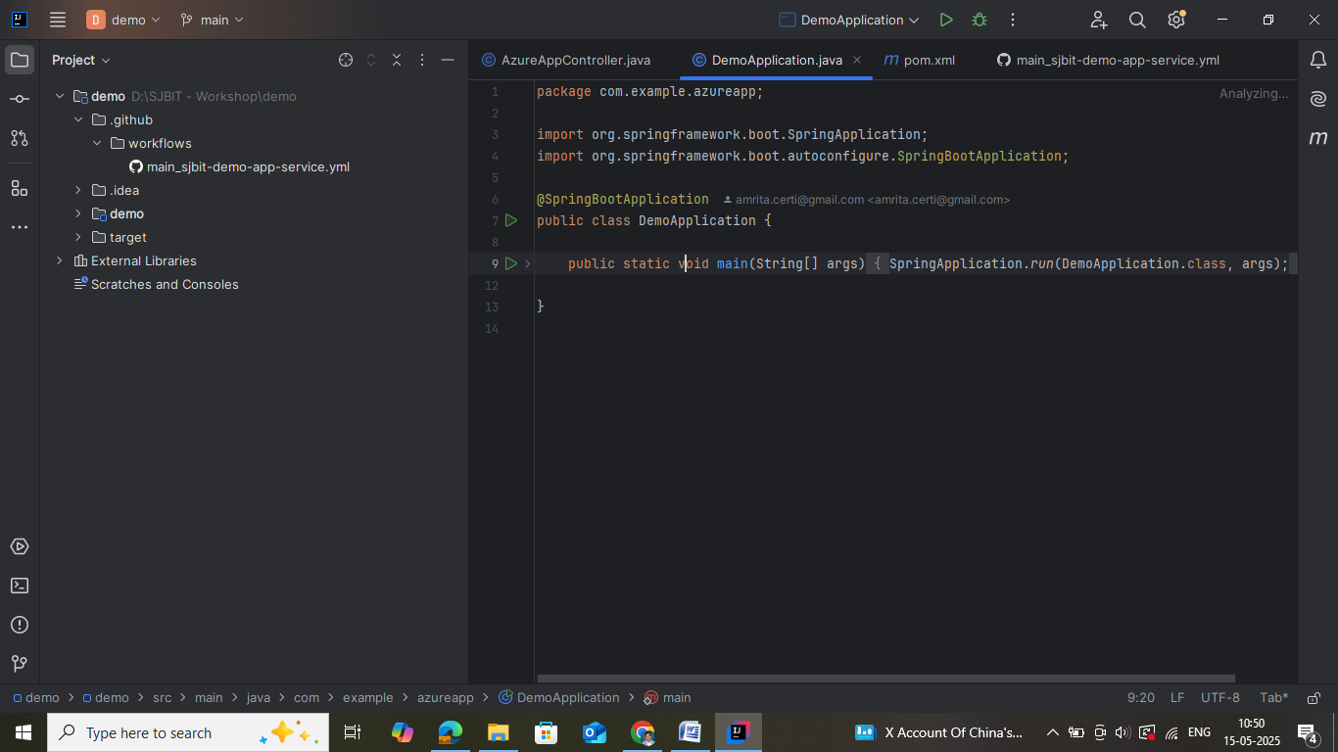
Running Status
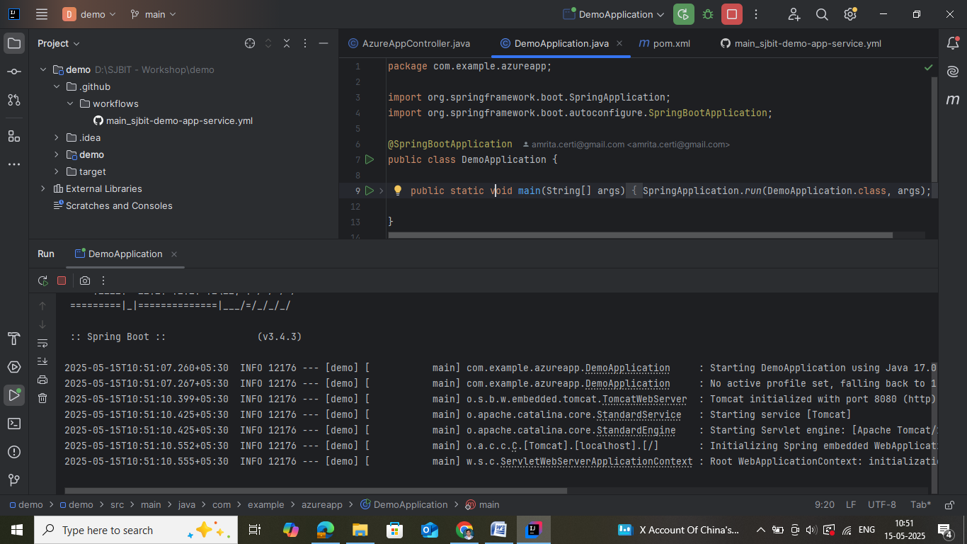
Step 3 : Open browser and verify the execution of Springboot application using the following URL
http://localhost:8080/api/data
Observe the following output
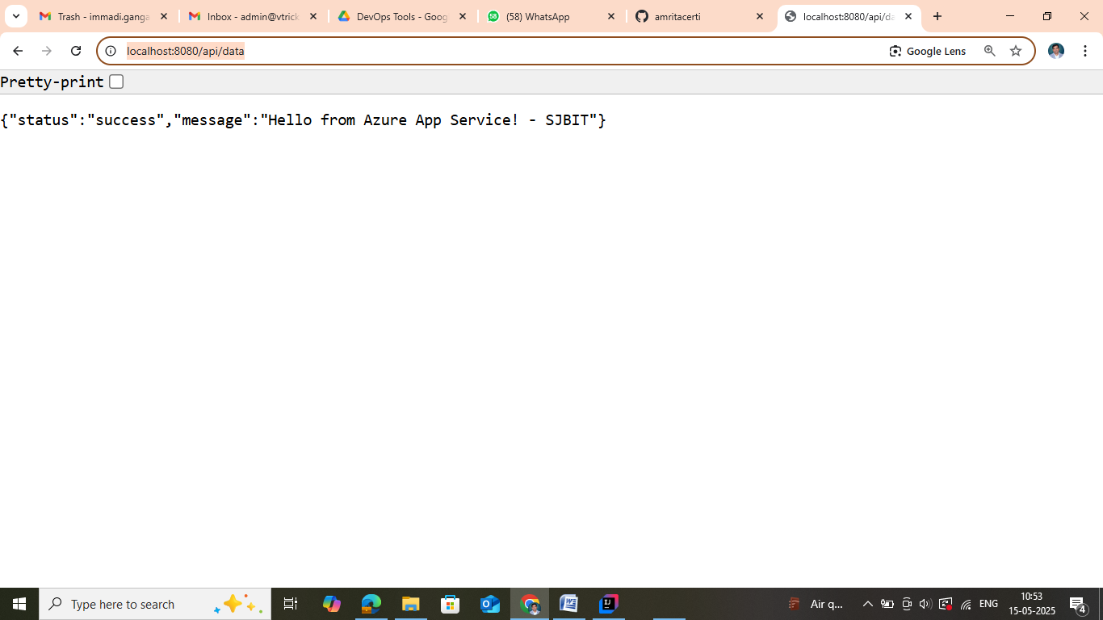
Step 4: Stop the SpringBoot Application after verification
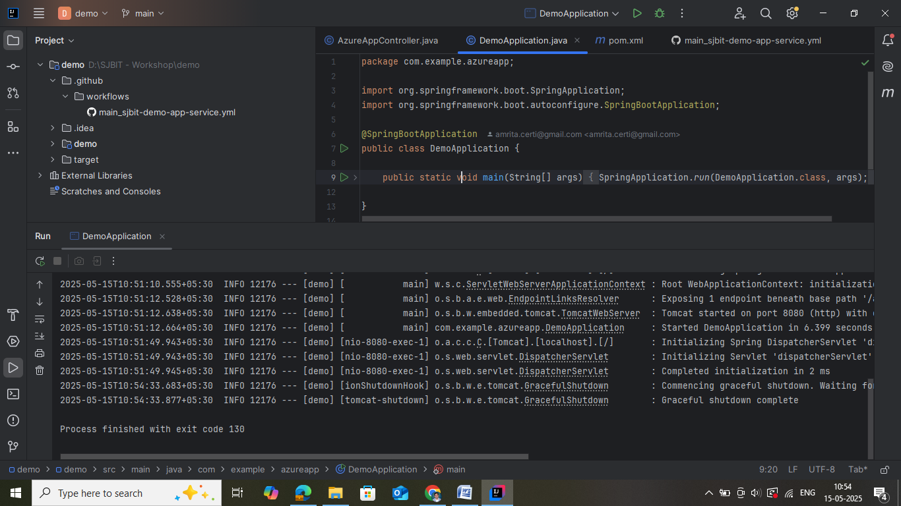
Step 5 : Create a repository in Git account and push the code

Code Pushing from local to github Repository.

Step 6 : Go to your github account and click on the New to create a new Repository.



Step 7: Provide Name for the Repository and choose it as Public Repository then click on create repository
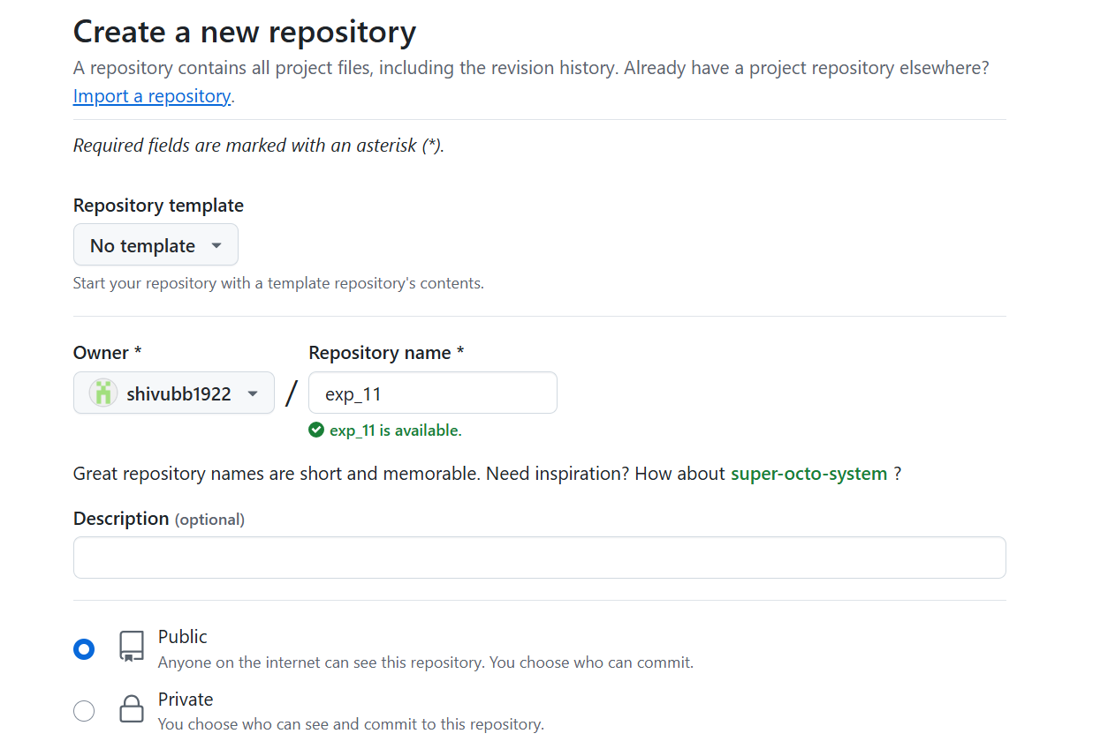
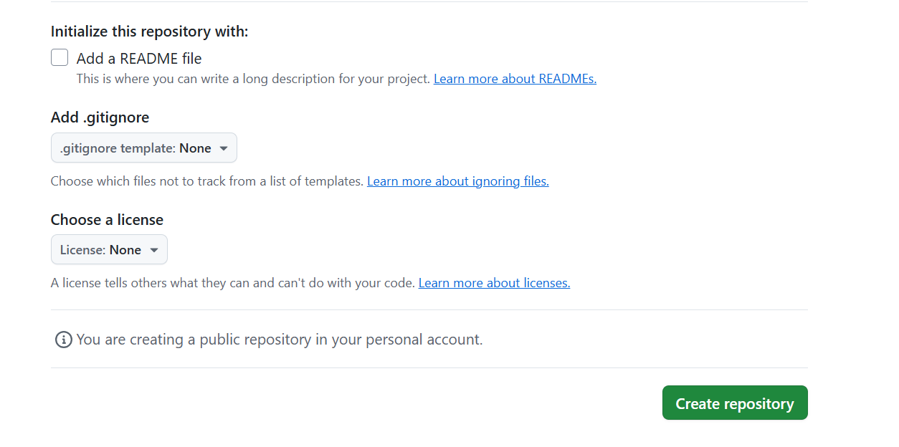
Step 8 : You will be getting https code for your Repository Created.

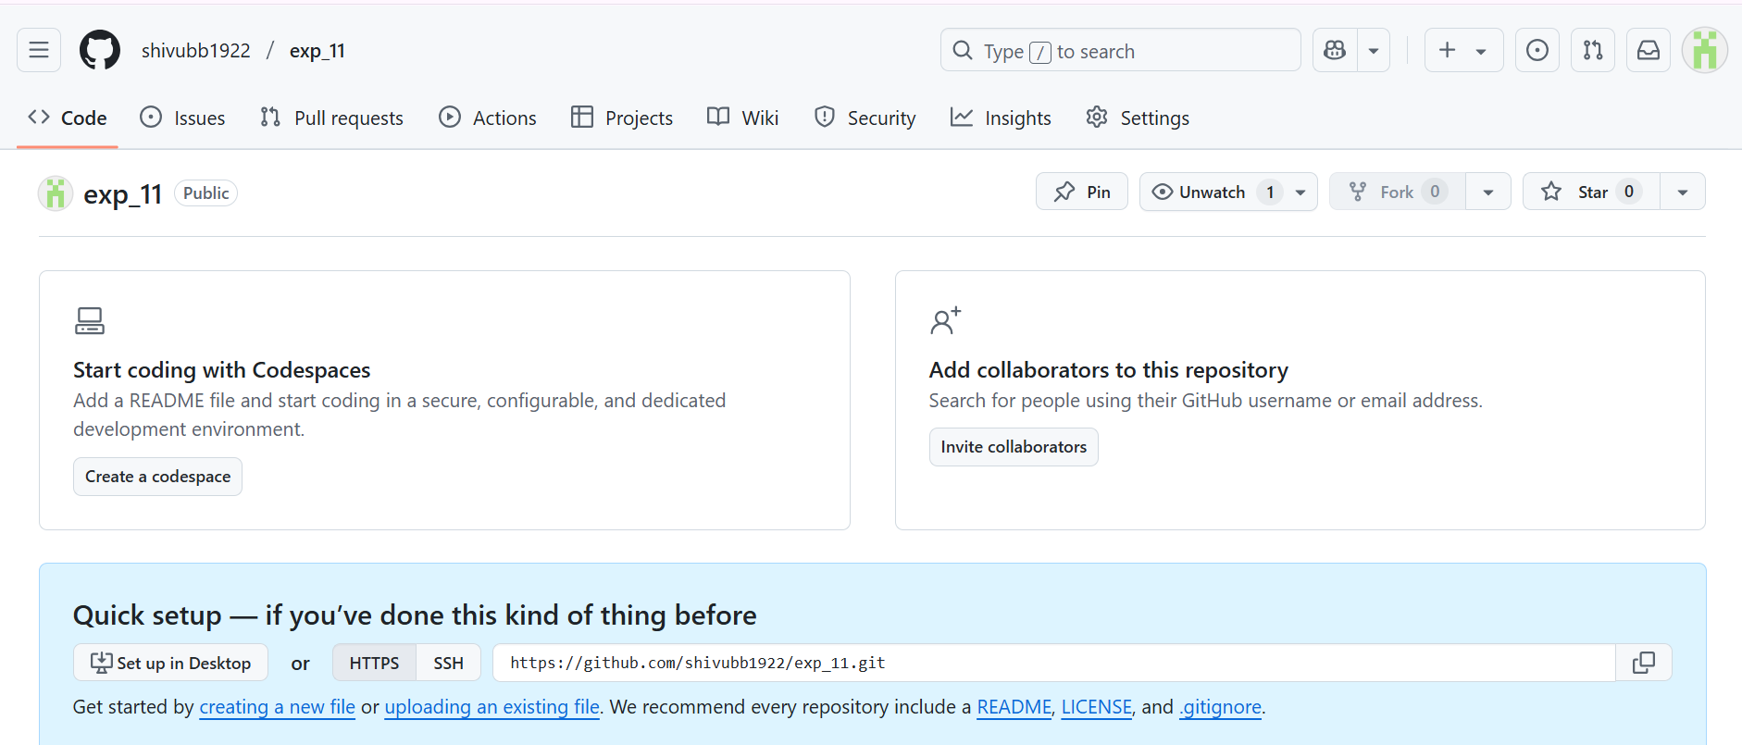
Step 9: Assuming your folders in C:\Users\Dell\Desktop\git\demo path

# Navigate to the correct directory
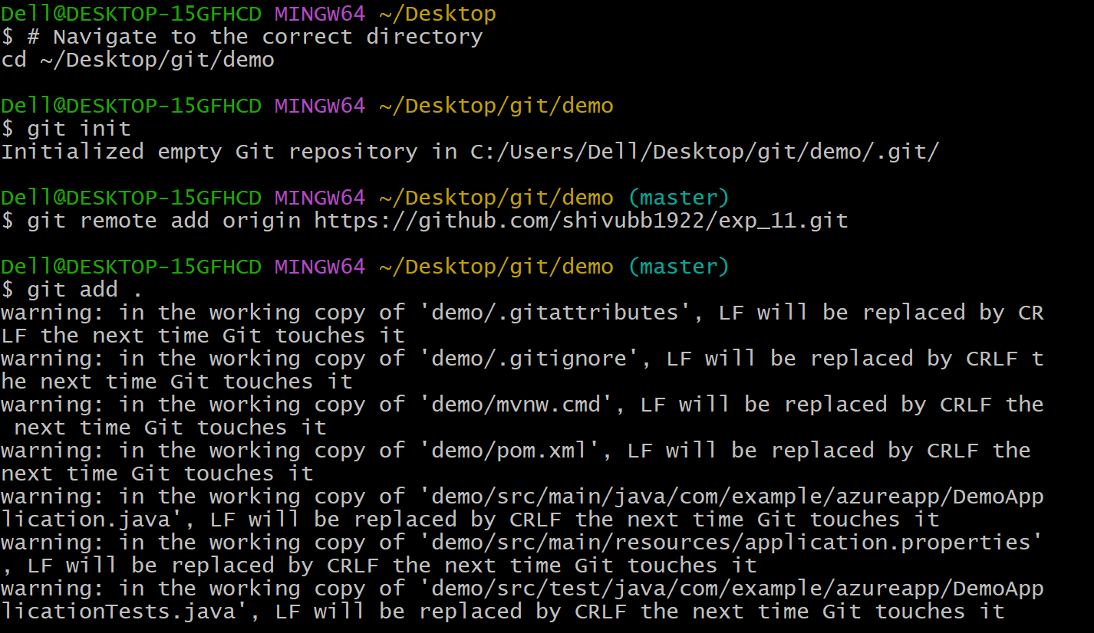

# Initialize git repo


# Add your new GitHub repo as remote


# Add all files/folders (demo/ and target/)


# Commit the changes
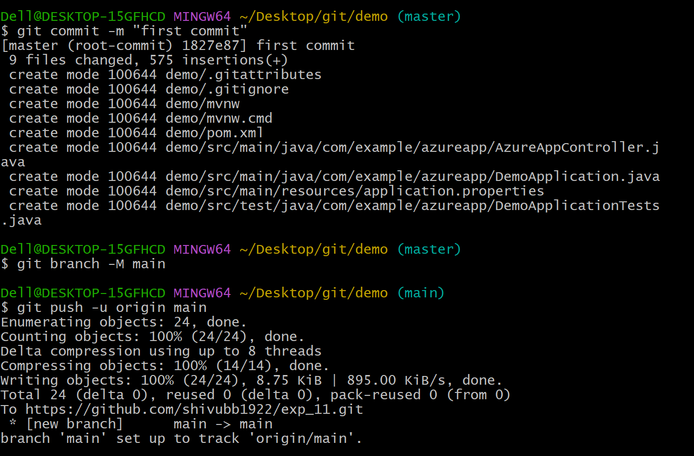

# Set default branch to main (optional if not already set)


# Push to GitHub

Step 10 : So, After that you will be getting all the files in your repository.
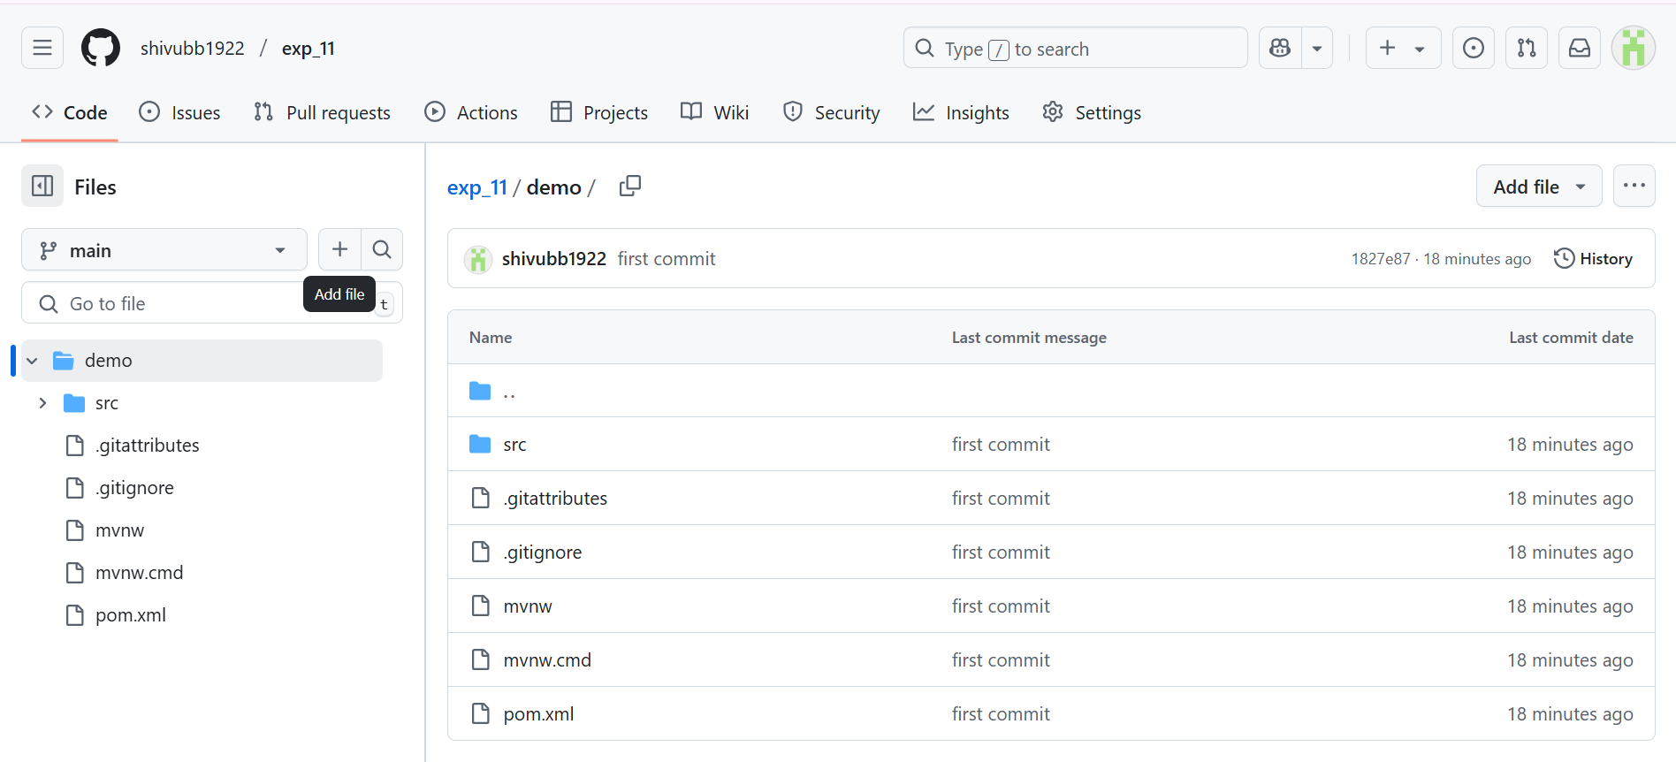

Step 11 : Login to Azure app service account using the following link
https://portal.azure.com/#home
Step 12: Home page of Azure service is as follows
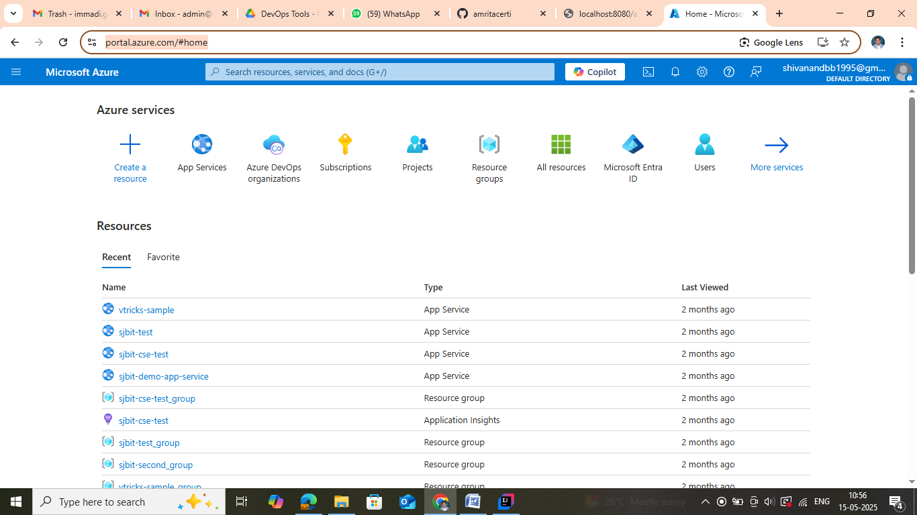
Step 13 : Go to App Service using the option mention in the following screen shot
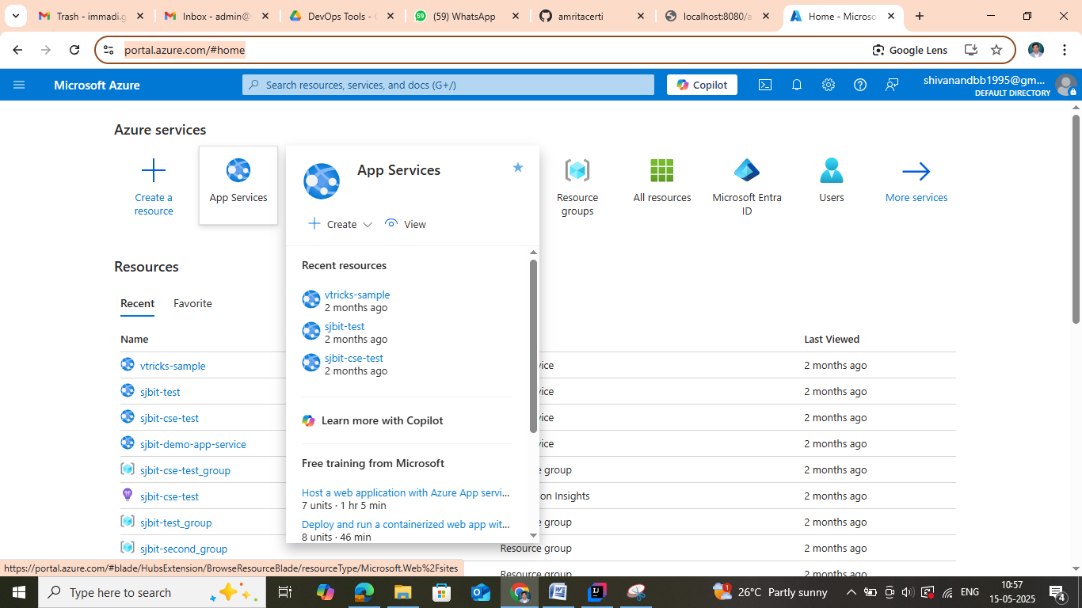
Step 14 : Home page of Azure AppService is given below
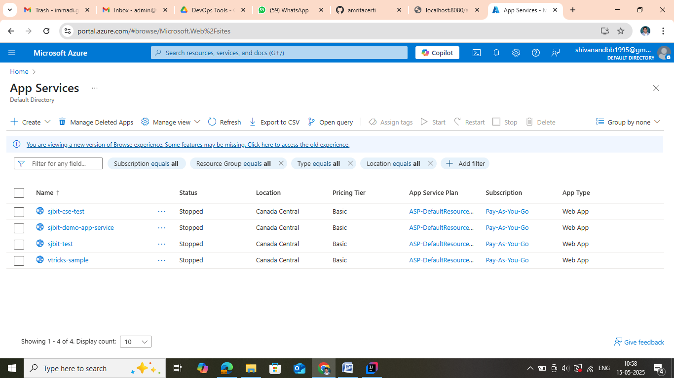
Step 15 : Create Web App by following the screenshot
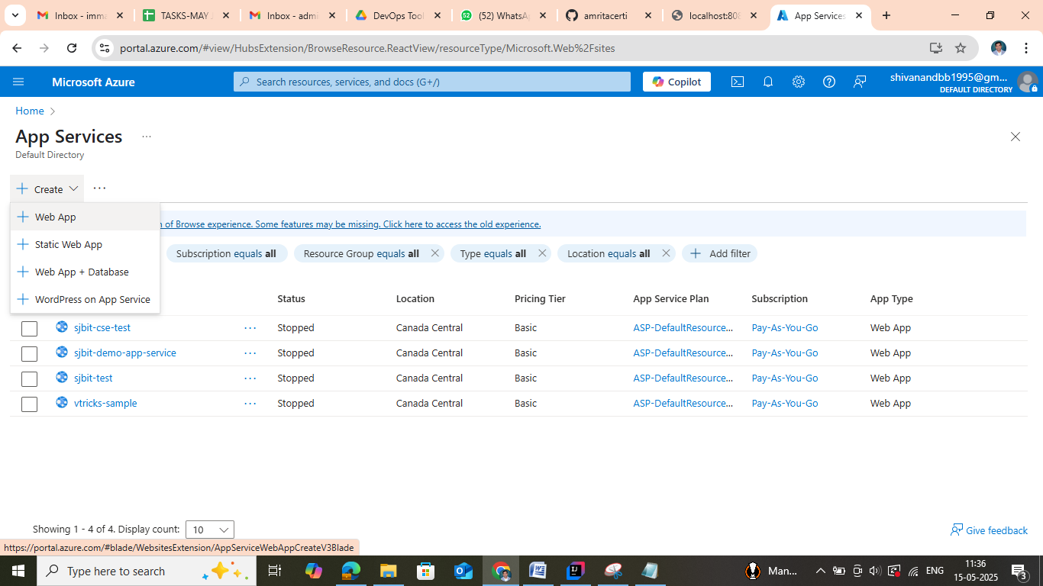
Step 16: Give name to the web application created
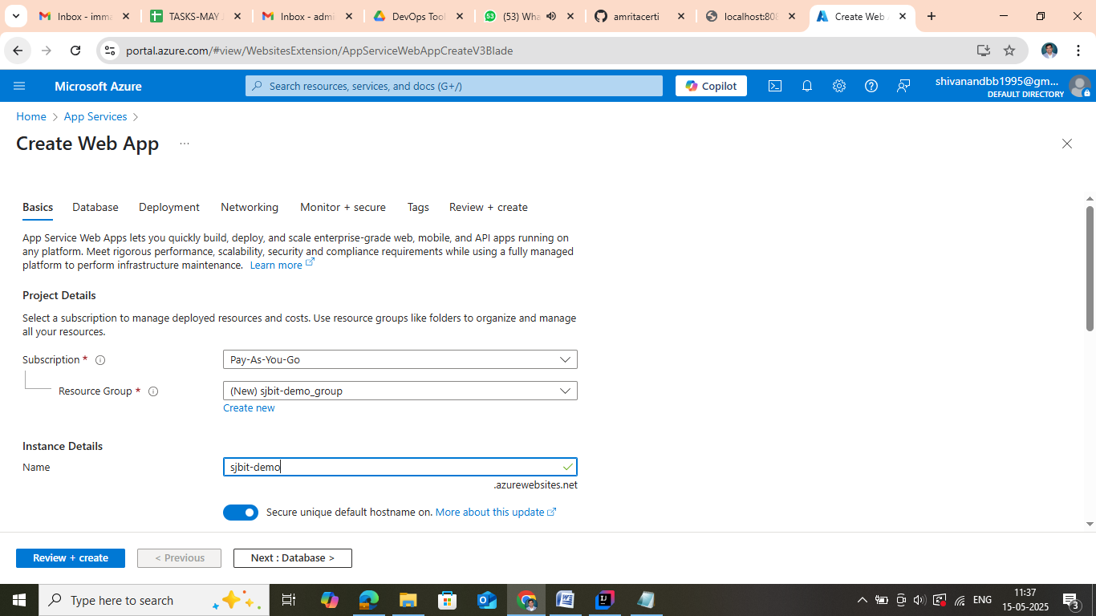
Step 17; Select Runtime Stack as Java17

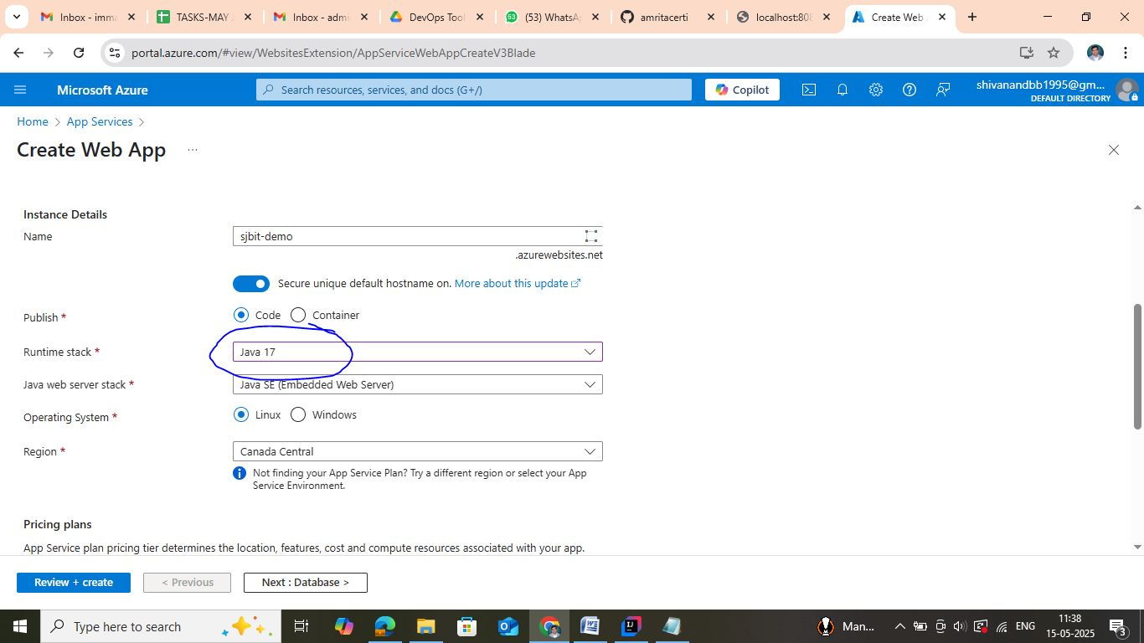
Step 18 : Select Linux plan -> go with default plan

Step 19: Navigate to Deployment and Enable Continuous Deployment
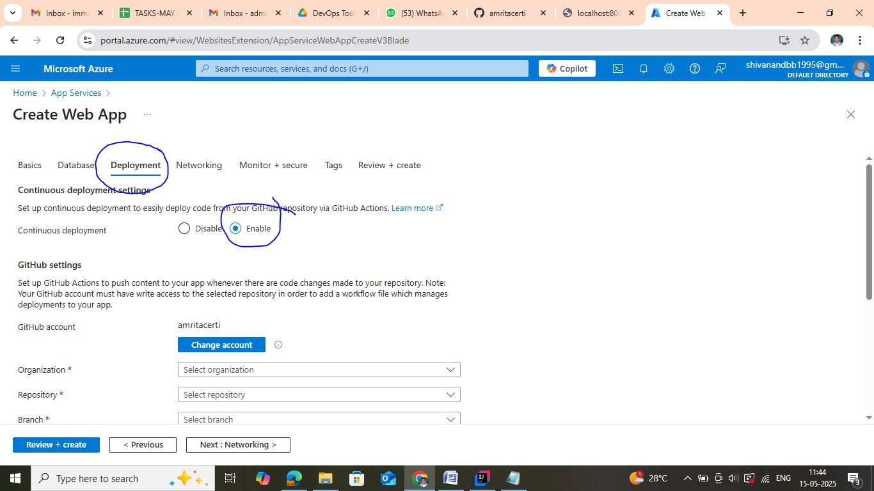
Step 20 : If you want to choose the git account, you can / select the git account , Select Organization , Select Repository , Select branch -> Main in this case

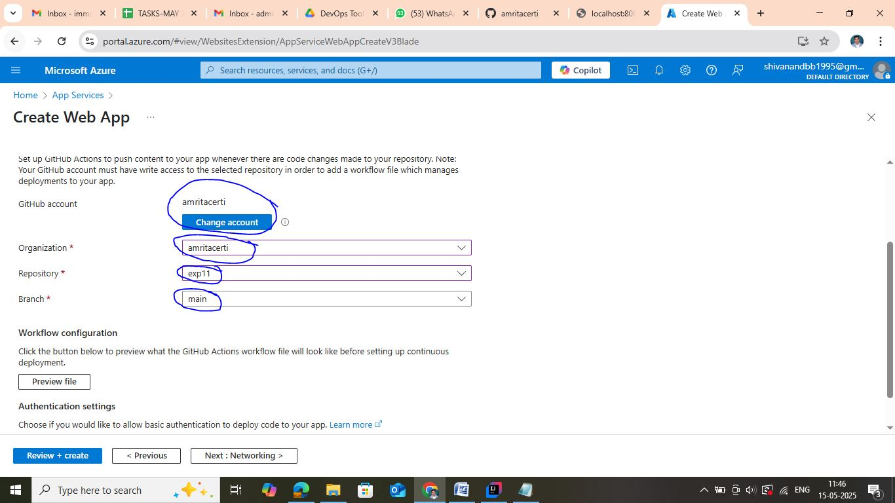
Step 21 : Enable Basic Authentication
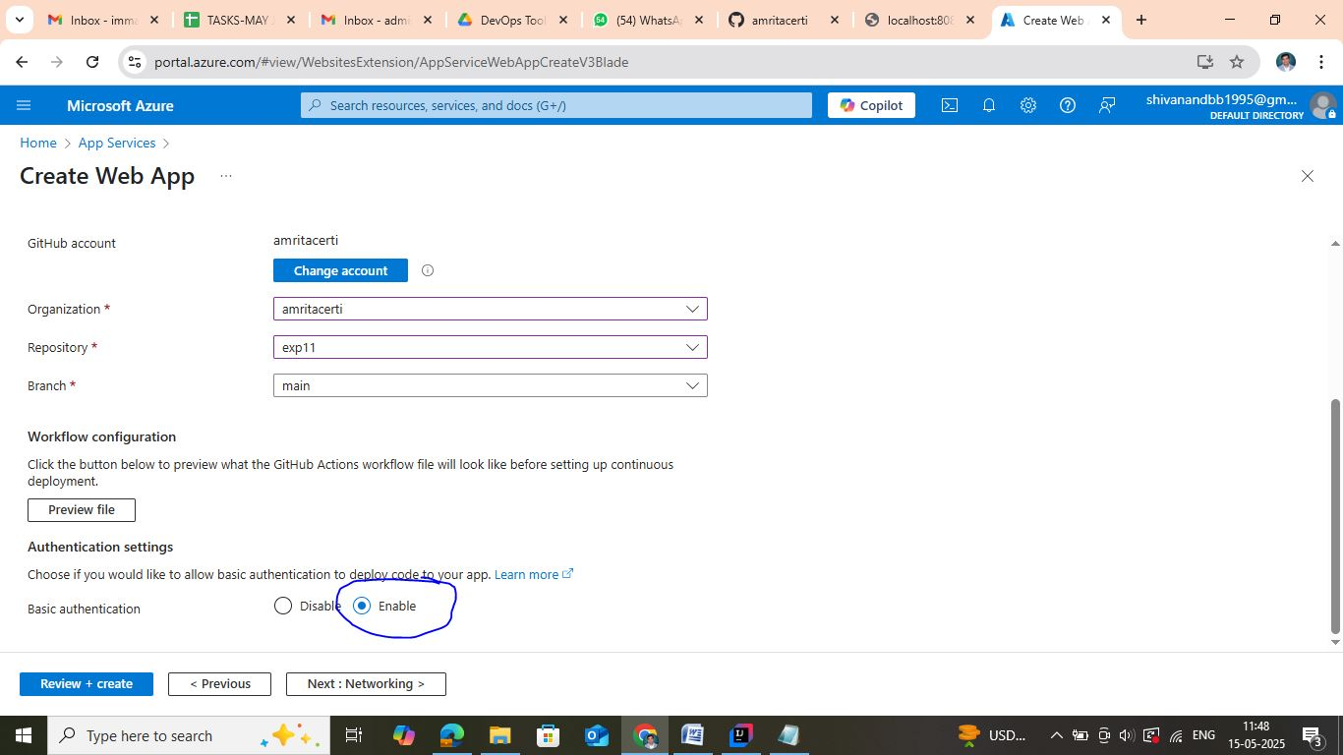

Step 22 : Click on Review and Create
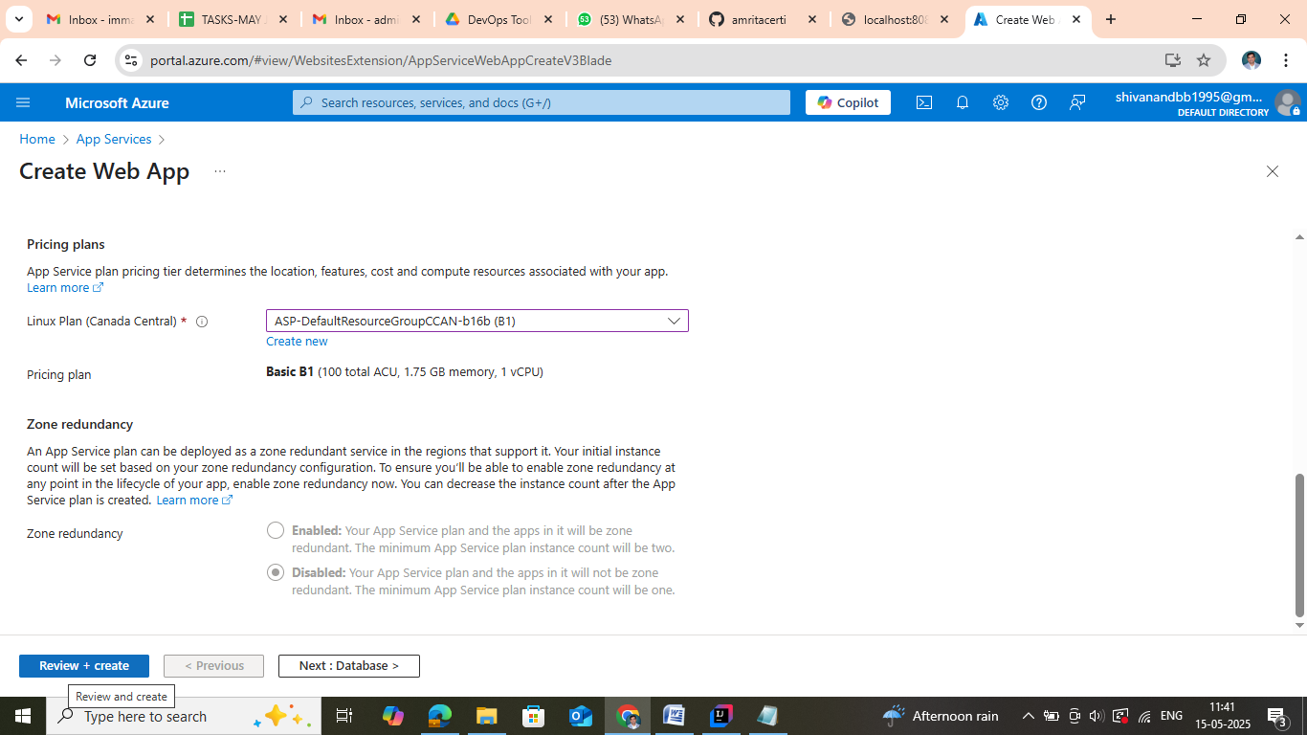
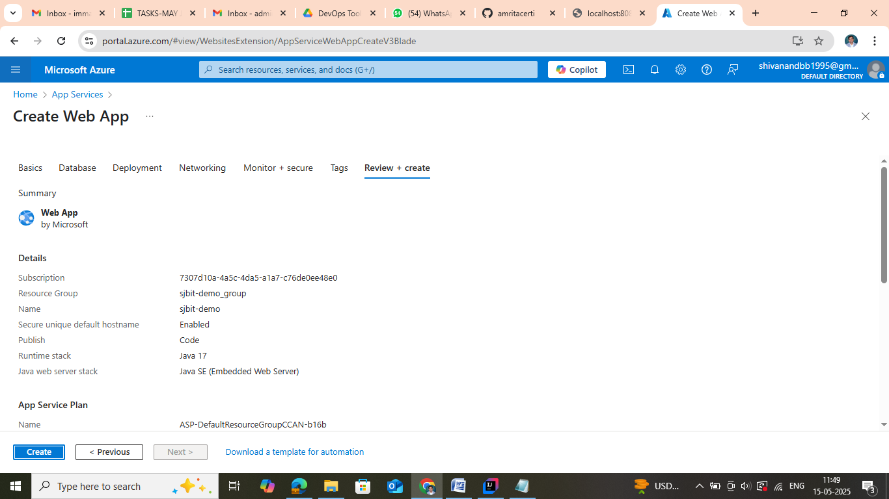
Step 23 : Click on Create -> Status shows as follows
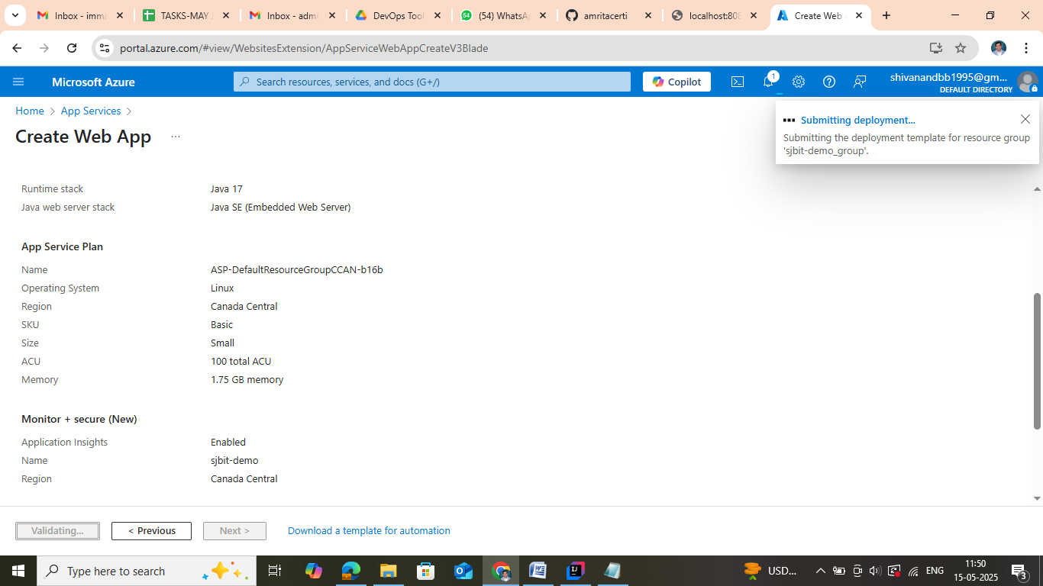
Step 24 : Deployment in progress
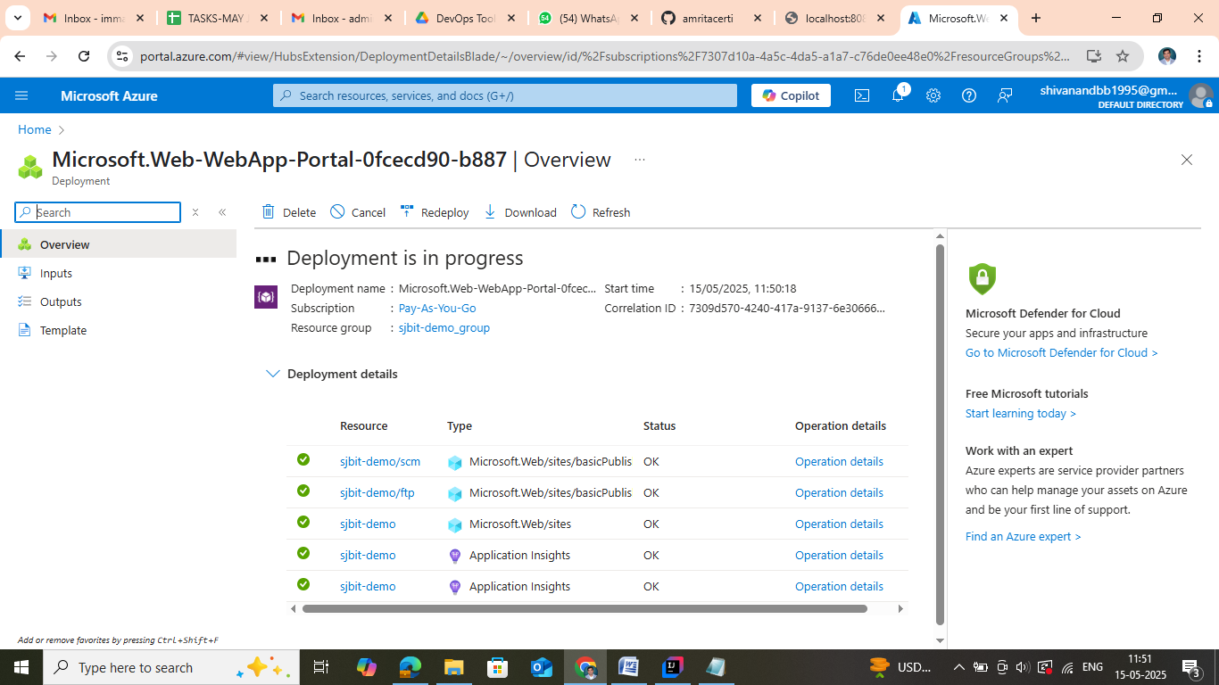
Step 25 : Click on go to resource and you will get the following view
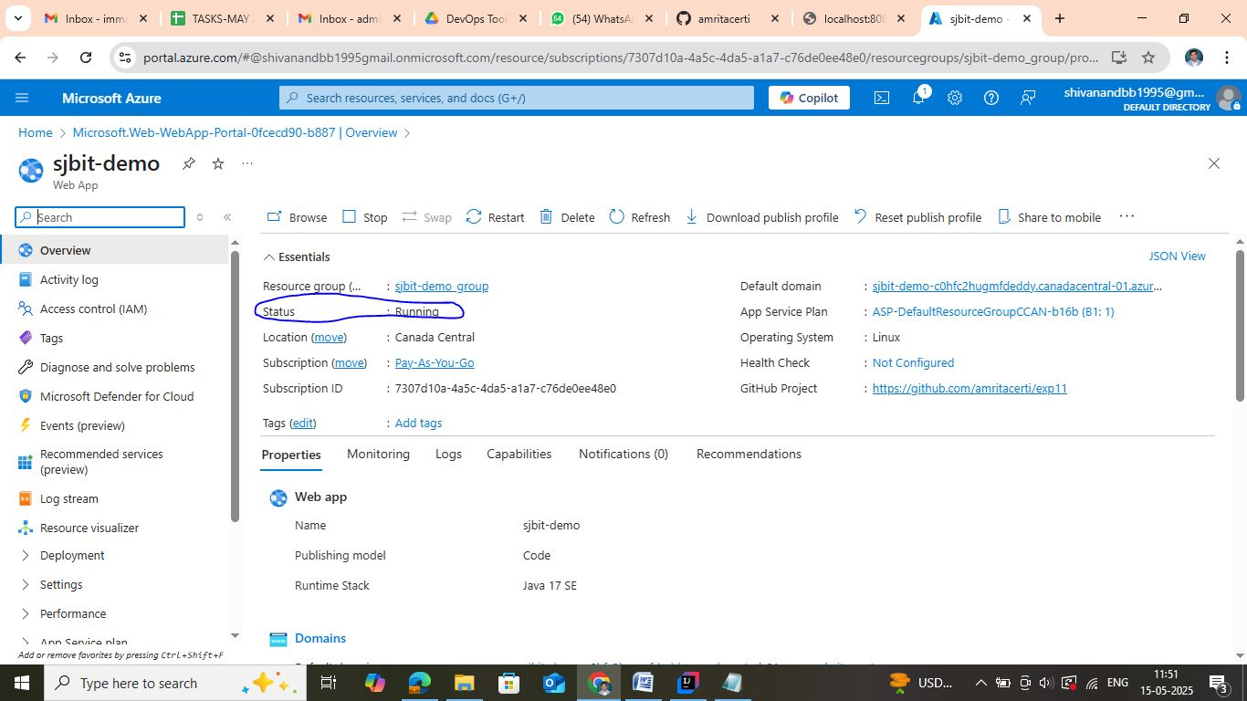
Step 26 : Copy the default domain link
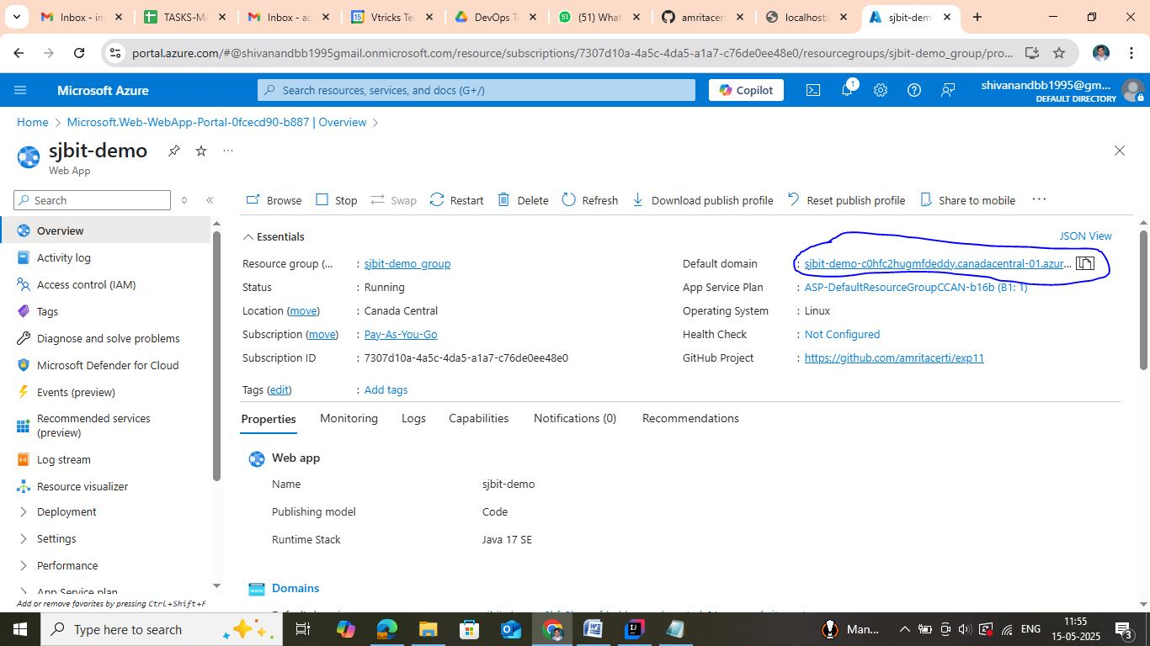
Step 27 : Paste the URL in browser and output looks as follows
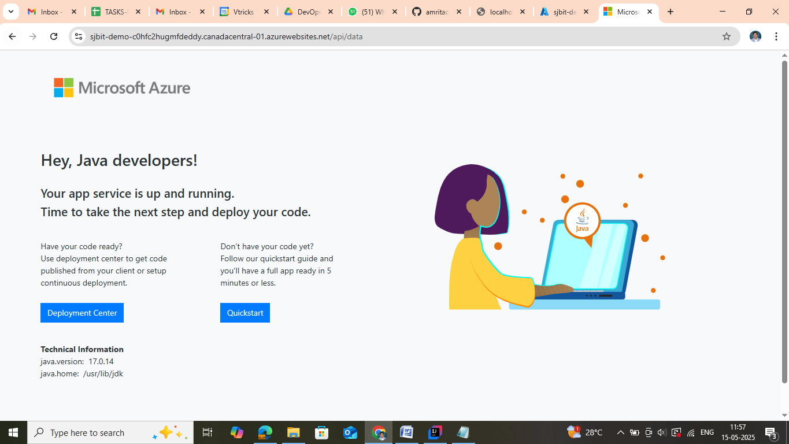
Step 28 : In Github Repository created by you -> Goto Actions
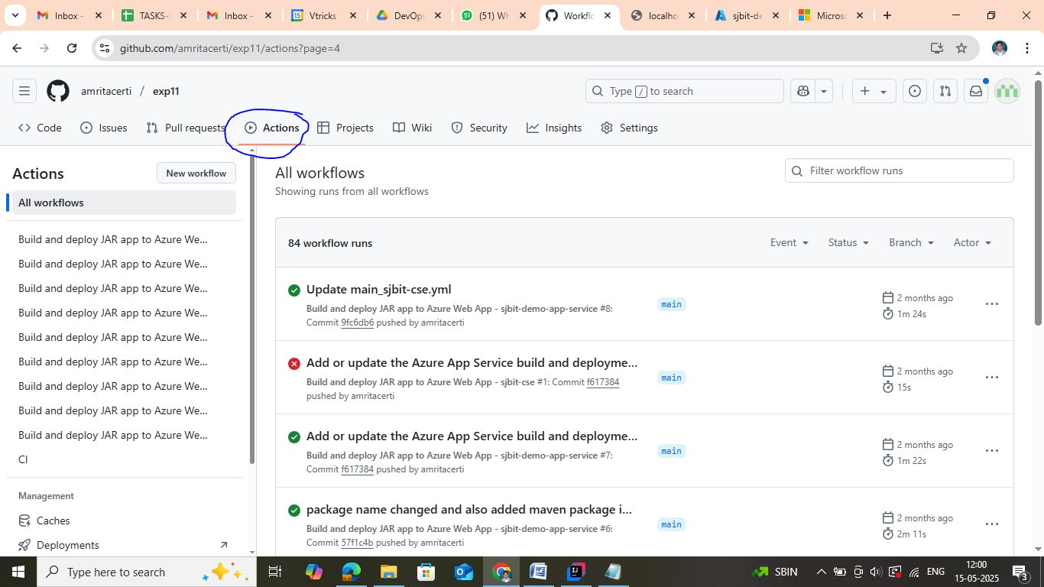

Step 29 : Create new workflow
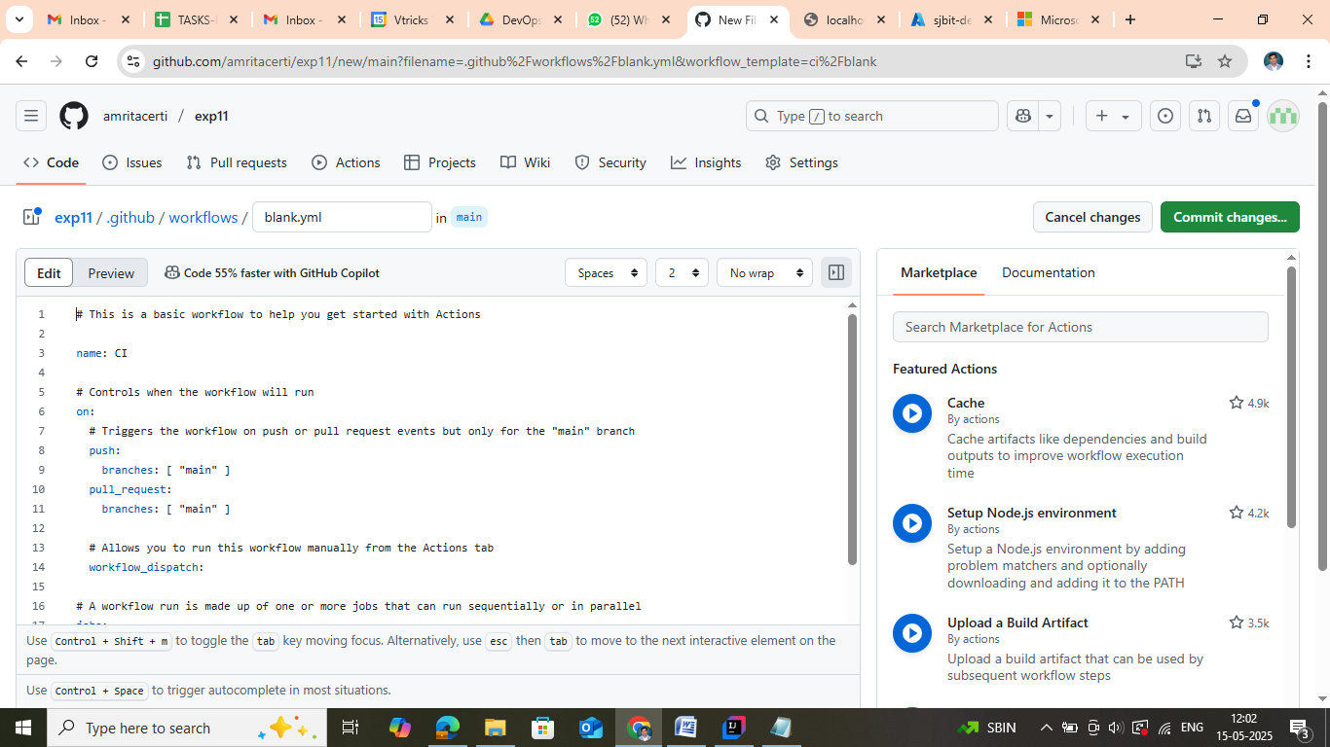
Step 30 : Copy Paste the following code to the for .github/workflows/main_sjbit-cse-test.yml
# Azure DevOps Pipeline for Building and Deploying a Spring Boot Application
name: Build and deploy JAR app to Azure Web App - sjbit-demo-app-service
on:
push:
branches:
- main
workflow_dispatch:
jobs:
build:
runs-on: ubuntu-latest
permissions:
contents: read # Required for actions/checkout
steps:
- name: Checkout Repository
uses: actions/checkout@v4
- name: Set up Java version
uses: actions/setup-java@v4
with:
java-version: '17'
distribution: 'microsoft'
- name: Build with Maven
run: mvn clean package
working-directory: demo # Ensures Maven runs inside the 'demo' directory
- name: Upload artifact for deployment job
uses: actions/upload-artifact@v4
with:
name: java-app
path: demo/target/sjbit-demo-app.jar # Uploads the specific JAR file
deploy:
runs-on: ubuntu-latest
needs: build
environment:
name: 'Production'
url: ${{ steps.deploy-to-webapp.outputs.webapp-url }}
permissions:
id-token: write # Required for requesting the JWT
contents: read # Required for actions/checkout
steps:
- name: Download artifact from build job
uses: actions/download-artifact@v4
with:
name: java-app
path: .
- name: Login to Azure
uses: azure/login@v2
with:
client-id: ${{ secrets.AZUREAPPSERVICE_CLIENTID_A82C0D7EDEBF47BABC8D778D03B5232F }}
tenant-id: ${{ secrets.AZUREAPPSERVICE_TENANTID_4F0B177E6FB24158AB21DE6A88CE21CE }}
subscription-id: ${{ secrets.AZUREAPPSERVICE_SUBSCRIPTIONID_0C5C87CB334A443B9BDB628D4029B69B }}
- name: Deploy to Azure Web App
id: deploy-to-webapp
uses: azure/webapps-deploy@v3
with:
app-name: 'sjbit-demo-app-service'
slot-name: 'Production'
package: 'sjbit-demo-app.jar' # Deploying the specific JAR file

